***E-Learning***

***Submitted by***

***Krishna Patel***

***Name of Student =Krishna Patel***

***Registration No.=12411316***

***Roll No.=51***

***Section=K24KP***

***in partial fulfillment for the award of the degree***

***of***

***BACHELOR OF COMPUTER SCIENCE and ENGINEERING***



***Lovely Professional University, Punjab***

***CSE326 – Internet Programming Laboratory***

***(CA-3)***

***DECEMBER, 2024***

***Introduction****:*

This is E-Learning website. It utilizes HTML, CSS, and JavaScript to create a visually appealing and user-friendly interface. The website features a navigation bar, a carousel for showcasing featured courses, and a grid layout for displaying course cards. The code also includes a basic footer section with navigation links and a subscription form. While this code provides a solid foundation, a fully functional e-learning platform would require additional backend components and functionalities like user authentication, course content management, and interactive learning experiences.

***Technology used:***

* **HTML (Hyper Text Markup Language):** This is the foundation of the website's structure and content. It defines the different sections, headings, paragraphs, navigation bar, footer section, div class, span class, UL, form class, and other elements on the page.
* **CSS (Cascading Style Sheets):** This is responsible for the website's visual design. It controls the layout, colors, fonts, and overall aesthetics of the webpage.
* **Bootstrap:** This is a popular front-end framework built on top of HTML and CSS. It provides pre-built components and styles that make it easier and faster to design responsive websites.
* **JavaScript:** While there isn't any complex JavaScript functionality included in this code snippet, JavaScript can be used to add interactivity to the website, such as dynamic content updates, animations, or form validation.

**Images:** The code references several images ("banner.png" files) that are used for the banner and course cards. These images would need to be uploaded to a web server to be displayed on the website

**Flowchart:**

***Project Description:***

This code appears to be for a basic e-learning website built with HTML, CSS (Bootstrap), and JavaScript. Here's a breakdown of the code's functionality:

* The code starts with an HTML document declaration (<!DOCTYPE html>) and specifies the character encoding (<meta charset="UTF-8">).
* It defines the viewport size for responsiveness (<meta name="viewport" content="width=device-width, initial-scale=1.0">).
* Links to Bootstrap CSS (<link href="https://cdn.jsdelivr.net/npm/bootstrap@5.3.3/dist/css/bootstrap.min.css" rel="stylesheet">) and JavaScript libraries (<script src="https://cdn.jsdelivr.net/npm/bootstrap@5.3.3/dist/js/bootstrap.bundle.min.js"></script>).
* The <title> tag specifies the page title ("Document" in this case).

**Navigation Bar:**

* A navigation bar is created using Bootstrap's navbar class.
* It includes a brand name (E-Learning) and navigation links (Home, Courses, Login, FAQ).
* Currently, the links seem disabled (class="nav-link disable").
* A search bar is included at the end of the navbar.

**Content Area:**

* A carousel component (carousel slide) displays featured content using multiple images (banner1.png, banner2.png, etc.).
* Below the carousel, a grid layout (row and col classes) displays course cards.
* Each course card is a Bootstrap card with an image, title, description, and a "Go somewhere" button (functionality not implemented).

**Footer:**

* The website footer includes sections (<h5>Section</h5>) with navigation links (Home, Features, etc.) likely repeated for different categories.
* A subscription form allows users to enter their email address.
* Copyright information and social media links are displayed.

**Overall, this code provides a basic structure for an e-learning website. However, it lacks functionalities like user login, course enrollment, and dynamic content. It also uses placeholder text and disabled links, suggesting it's under development.**

*Project Objectives***:**

* Develop a user-friendly e-learning website to provide online courses in various programming languages and web development.

**Specific Objectives:**

* Design and implement a visually appealing and responsive website using HTML, CSS (Bootstrap), and JavaScript.
* Create a navigation bar allowing users to explore the website's sections (Home, Courses, Login, FAQ).
* Develop a carousel to display featured courses or promotional content.
* Design course cards with images, titles, descriptions, and call-to-action buttons.
* Integrate a search bar to enable users to find specific courses.
* Implement a subscription form to capture user email addresses for newsletters or updates (future development).
* Create a footer section with navigation links, social media icons, and copyright information.

**Additional Considerations:**

* While the current code provides a basic structure, functionalities like user login, course enrollment, and dynamic content need to be implemented for a fully functional e-learning platform.
* Consider incorporating accessibility features to ensure the website is usable by everyone.

These objectives can be further refined based on specific project requirements and priorities.

*Expected outcomes of project:*

*.Based on the provided code, the expected outcome of the project is a basic e-learning website with the following functionalities:*

***Layout and Design:***

* *A visually appealing website using Bootstrap for responsive design that adapts to different screen sizes.*
* *A navigation bar with links to "Home", "Courses", "Login", and "FAQ" sections.*
* *A carousel displaying featured courses or promotional content.*
* *Course cards with images, titles, descriptions, and call-to-action buttons.*

***User Interaction:***

* *A search bar allowing users to find specific courses.*
* *Functional links in the navigation bar and footer for easy website exploration.*

***Content:***

* *Placeholder content for course descriptions and titles.*
* *Sample images for the carousel and course cards.*

***Additional Considerations:***

* *While the code includes a subscription form in the footer, it's not currently functional.*
* *The navigation bar links ("Home", "Courses", etc.) are currently disabled and don't lead to separate pages.*

*Overall, this code provides a good starting point for an e-learning website. However, to make it a fully functional platform, further development is needed to implement features like:*

* *User login and account creation*
* *Course enrollment and progress tracking*
* *Dynamic course content and descriptions*
* *Functional search functionality*
* *Integration with a payment gateway (if offering paid courses)*

*By adding these features and refining the design and content, you can create a user-friendly and informative e-learning website*

***[Firstpage.html]***

*<!DOCTYPE html>*

*<html lang="en">*

*<head>*

*<meta charset="UTF-8">*

*<meta name="viewport" content="width=device-width, initial-scale=1.0">*

*<link href="https://cdn.jsdelivr.net/npm/bootstrap@5.3.3/dist/css/bootstrap.min.css" rel="stylesheet"*

*integrity="sha384-QWTKZyjpPEjISv5WaRU9OFeRpok6YctnYmDr5pNlyT2bRjXh0JMhjY6hW+ALEwIH" crossorigin="anonymous">*

*<script src="https://cdn.jsdelivr.net/npm/bootstrap@5.3.3/dist/js/bootstrap.bundle.min.js"*

*integrity="sha384-YvpcrYf0tY3lHB60NNkmXc5s9fDVZLESaAA55NDzOxhy9GkcIdslK1eN7N6jIeHz"*

*crossorigin="anonymous"></script>*

*<title>Document</title>*

*</head>*

*<body>*

*<nav class="navbar navbar-expand-lg bg-body-tertiary">*

*<div class="container-fluid">*

*<a class="navbar-brand" href="#">E-Learning</a>*

*<button class="navbar-toggler" type="button" data-bs-toggle="collapse"*

*data-bs-target="#navbarSupportedContent" aria-controls="navbarSupportedContent" aria-expanded="false"*

*aria-label="Toggle navigation">*

*<span class="navbar-toggler-icon"></span>*

*</button>*

*<div class="collapse navbar-collapse" id="navbarSupportedContent">*

*<ul class="navbar-nav me-auto mb-2 mb-lg-0">*

*<li class="nav-item">*

*<a class="nav-link disable" aria-current="page" href="#">Home</a>*

*</li>*

*<li class="nav-item">*

*<a class="nav-link disable" aria-current="page" href="course.html">courses</a>*

*</li>*

*<li class="nav-item">*

*<a class="nav-link disable" aria-current="page" href="Login.html">Login</a>*

*</li>*

*<!-- <li class="Login.html">*

*<a class="nav-link disabled" aria-disabled="true">Login</a>*

*</li> -->*

*<li class="nav-item">*

*<a class="nav-link disable" aria-current="page" href="FAQ.html">FAQ</a>*

*</li*

*</ul>*

*<form class="d-flex" role="search">*

*<input class="form-control me-2" type="search" placeholder="Search" aria-label="Search">*

*<button class="btn btn-outline-success" type="submit">Search</button>*

*</form>*

*</div>*

*</div>*

*</nav>*

*<!-- <div class="spinner-border" role="status">*

*<span class="visually-hidden">Loading...</span>*

*</div>*

*-->*

*<div class="container text-center">*

*<div class="row align-items-center mt-5">*

*<div class="col">*

*<div class="card" style="width: 18rem;">*

*<img src="digi1.png" class="card-img-top" alt="...">*

*<div class="card-body">*

*<h5 class="card-title">Card title</h5>*

*<p class="card-text">This course is designed for begineers in c and c++.</p>*

*<a href="javascript0.html" class="btn btn-primary">View detail</a>*

*</div>*

*</div> --*

*</div>*

*<div class="col">*

*<div class="card" style="width: 18rem;">*

*<img src="digi2.png" class="card-img-top" alt="...">*

*<div class="card-body">*

*<h5 class="card-title">Card title</h5>*

*<p class="card-text">Java course! In this extensive instruction, acquire the essentials of java programming technology.</p>*

*<a href="javascript0.html" class="btn btn-primary">View detail</a>*

*</div>*

*</div> --*

*</div>*

*<div class="col">*

*<div class="card" style="width: 18rem;">*

*<img src="digi3.png" class="card-img-top" alt="...">*

*<div class="card-body">*

*<h5 class="card-title">Card title</h5>*

*<p class="card-text">Javascript, the key language for developing websites. Students will study the basic principles of janascript.*

*</p>*

*<a href="javascript0.html" class="btn btn-primary">View detail</a>*

*</div>*

*</div>*

*</div>*

*<div class="col">*

*<div class="card" style="width: 18rem;">*

*<img src="digi4.png" class="card-img-top" alt="...">*

*<div class="card-body">*

*<h5 class="card-title">Card title</h5>*

*<p class="card-text">This course is designed for web development requiring web developors.*

*</p>*

*<a href="javascript0.html" class="btn btn-primary">View detail</a>*

*</div>*

*</div>*

*</div>*

*</div>*

*<div class="row align-items-center">*

*<div class="col">*

*<div class="card" style="width: 18rem;">*

*<img src="digi5.png" class="card-img-top" alt="...">*

*<div class="card-body">*

*<h5 class="card-title">Card title</h5>*

*<p class="card-text">Java course! In this extensive instruction, acquire the essentials of java programming technology.*

*</p>*

*<a href="javascript0.html" class="btn btn-primary">View detail</a>*

*</div>*

*</div> --*

*</div>*

*<div class="col">*

*<div class="card" style="width: 18rem;">*

*<img src="digi6.png" class="card-img-top" alt="...">*

*<div class="card-body">*

*<h5 class="card-title">Card title</h5>*

*<p class="card-text">Javascript, the key language for developing websites. Students will study the basic principles of janascript*

*</p>*

*<a href="javascript0.html" class="btn btn-primary">View detail</a>*

*</div>*

*</div> --*

*</div>*

*<div class="col">*

*<div class="card" style="width: 18rem;">*

*<img src="digi7.png" class="card-img-top" alt="...">*

*<div class="card-body">*

*<h5 class="card-title">Card title</h5>*

*<p class="card-text">This course gives an in-depth review of PHP, an effective serve-side programming language widely used in the world.*

*</p>*

*<a href="javascript0.html" class="btn btn-primary">View detail</a>*

*</div>*

*</div>*

*</div>*

*<div class="col">*

*<div class="card" style="width: 18rem;">*

*<img src="digi8.png" class="card-img-top" alt="...">*

*<div class="card-body">*

*<h5 class="card-title">Card title</h5>*

*<p class="card-text"><h2>Snowflake Fundamentals 4- Day Priavate</h2>*

*</p>*

*<a href="javascript0.html" class="btn btn-primary">View detail</a>*

*</div>*

*</div>*

*</div>*

*</div>*

*<script src="https://cdn.jsdelivr.net/npm/@popperjs/core@2.11.8/dist/umd/popper.min.js"*

*integrity="sha384-I7E8VVD/ismYTF4hNIPjVp/Zjvgyol6VFvRkX/vR+Vc4jQkC+hVqc2pM8ODewa9r"*

*crossorigin="anonymous"></script>*

*<script src="https://cdn.jsdelivr.net/npm/bootstrap@5.3.3/dist/js/bootstrap.min.js"*

*integrity="sha384-0pUGZvbkm6XF6gxjEnlmuGrJXVbNuzT9qBBavbLwCsOGabYfZo0T0to5eqruptLy"*

*crossorigin="anonymous"></script>*

*</body>*

*</html>*

***[Secondpage.html]***

*!DOCTYPE html>*

*<html lang="en">*

*<head>*

*<meta charset="UTF-8">*

*<meta name="viewport" content="width=device-width, initial-scale=1.0">*

*<link href="https://cdn.jsdelivr.net/npm/bootstrap@5.3.3/dist/css/bootstrap.min.css" rel="stylesheet"*

*integrity="sha384-QWTKZyjpPEjISv5WaRU9OFeRpok6YctnYmDr5pNlyT2bRjXh0JMhjY6hW+ALEwIH" crossorigin="anonymous">*

*<script src="https://cdn.jsdelivr.net/npm/bootstrap@5.3.3/dist/js/bootstrap.bundle.min.js"*

*integrity="sha384-YvpcrYf0tY3lHB60NNkmXc5s9fDVZLESaAA55NDzOxhy9GkcIdslK1eN7N6jIeHz"*

*crossorigin="anonymous"></script>*

*<title>Document</title>*

*</head>*

*<body>*

*<div class="accordion accordion-flush" id="accordionFlushExample">*

*<div class="accordion-item">*

*<h2 class="accordion-header">*

*<button class="accordion-button collapsed" type="button" data-bs-toggle="collapse" data-bs-target="#flush-collapseOne" aria-expanded="false" aria-controls="flush-collapseOne">*

*Accordion Item #1*

*</button>*

*</h2>*

*<div id="flush-collapseOne" class="accordion-collapse collapse" data-bs-parent="#accordionFlushExample">*

*<div class="accordion-body">Placeholder content for this accordion, which is intended to demonstrate the <code>.accordion-flush</code> class. This is the first item's accordion body.</div>*

*</div>*

*</div>*

*<div class="accordion-item">*

*<h2 class="accordion-header">*

*<button class="accordion-button collapsed" type="button" data-bs-toggle="collapse" data-bs-target="#flush-collapseTwo" aria-expanded="false" aria-controls="flush-collapseTwo">*

*Accordion Item #2*

*</button>*

*</h2>*

*<div id="flush-collapseTwo" class="accordion-collapse collapse" data-bs-parent="#accordionFlushExample">*

*<div class="accordion-body">Placeholder content for this accordion, which is intended to demonstrate the <code>.accordion-flush</code> class. This is the second item's accordion body. Let's imagine this being filled with some actual content.</div>*

*</div>*

*</div>*

*<div class="accordion-item">*

*<h2 class="accordion-header">*

*<button class="accordion-button collapsed" type="button" data-bs-toggle="collapse" data-bs-target="#flush-collapseThree" aria-expanded="false" aria-controls="flush-collapseThree">*

*Accordion Item #3*

*</button>*

*</h2>*

*<div id="flush-collapseThree" class="accordion-collapse collapse" data-bs-parent="#accordionFlushExample">*

*<div class="accordion-body">Placeholder content for this accordion, which is intended to demonstrate the <code>.accordion-flush</code> class. This is the third item's accordion body. Nothing more exciting happening here in terms of content, but just filling up the space to make it look, at least at first glance, a bit more representative of how this would look in a real-world application.</div>*

*</div>*

*</div>*

*</div>*

*<script src="https://cdn.jsdelivr.net/npm/@popperjs/core@2.11.8/dist/umd/popper.min.js"*

*integrity="sha384-I7E8VVD/ismYTF4hNIPjVp/Zjvgyol6VFvRkX/vR+Vc4jQkC+hVqc2pM8ODewa9r"*

*crossorigin="anonymous"></script>*

*<script src="https://cdn.jsdelivr.net/npm/bootstrap@5.3.3/dist/js/bootstrap.min.js"*

*integrity="sha384-0pUGZvbkm6XF6gxjEnlmuGrJXVbNuzT9qBBavbLwCsOGabYfZo0T0to5eqruptLy"*

*crossorigin="anonymous"></script>*

*</body>*

*</html>*

***[Thirdpage.html]***

***<!DOCTYPE html>***

***<html lang="en">***

***<head>***

***<meta charset="UTF-8">***

***<meta name="viewport" content="width=device-width, initial-scale=1.0">***

***<link href="https://cdn.jsdelivr.net/npm/bootstrap@5.3.3/dist/css/bootstrap.min.css" rel="stylesheet"***

***integrity="sha384-QWTKZyjpPEjISv5WaRU9OFeRpok6YctnYmDr5pNlyT2bRjXh0JMhjY6hW+ALEwIH" crossorigin="anonymous">***

***<script src="https://cdn.jsdelivr.net/npm/bootstrap@5.3.3/dist/js/bootstrap.bundle.min.js"***

***integrity="sha384-YvpcrYf0tY3lHB60NNkmXc5s9fDVZLESaAA55NDzOxhy9GkcIdslK1eN7N6jIeHz"***

***crossorigin="anonymous"></script>***

***<title>Document</title>***

***</head>***

***<body>***

***<nav class="navbar navbar-expand-lg bg-body-tertiary">***

***<div class="container-fluid">***

***<a class="navbar-brand" href="#">E-Learning</a>***

***<button class="navbar-toggler" type="button" data-bs-toggle="collapse"***

***data-bs-target="#navbarSupportedContent" aria-controls="navbarSupportedContent" aria-expanded="false"***

***aria-label="Toggle navigation">***

***<span class="navbar-toggler-icon"></span>***

***</button>***

***<div class="collapse navbar-collapse" id="navbarSupportedContent">***

***<ul class="navbar-nav me-auto mb-2 mb-lg-0">***

***<li class="nav-item">***

***<a class="nav-link disable" aria-current="page" href="#">Home</a>***

***</li>***

***<li class="nav-item">***

***<a class="nav-link disable" aria-current="page" href="course.html">courses</a>***

***</li>***

***<li class="nav-item">***

***<a class="nav-link disable" aria-current="page" href="act11.html">Login</a>***

***</li>***

***<!-- <li class="Login.html">***

***<a class="nav-link disabled" aria-disabled="true">Login</a>***

***</li> -->***

***<li class="nav-item">***

***<a class="nav-link disable" aria-current="page" href="FAQ.html">FAQ</a>***

***</li***

***</ul>***

***<form class="d-flex" role="search">***

***<input class="form-control me-2" type="search" placeholder="Search" aria-label="Search">***

***<button class="btn btn-outline-success" type="submit">Search</button>***

***</form>***

***</div>***

***</div>***

***</nav>***

***<div id="carouselExample" class="carousel slide">***

***<div class="carousel-inner">***

***<div class="carousel-item active">***

***<img src="banner1.png" class="d-block w-100" alt="...">***

***</div>***

***<div class="carousel-item">***

***<img src="banner2.png" class="d-block w-100" alt="...">***

***</div>***

***<div class="carousel-item">***

***<img src="banner4.png" class="d-block w-100" alt="...">***

***</div>***

***</div>***

***<button class="carousel-control-prev" type="button" data-bs-target="#carouselExample" data-bs-slide="prev">***

***<span class="carousel-control-prev-icon" aria-hidden="true"></span>***

***<span class="visually-hidden">Previous</span>***

***</button>***

***<button class="carousel-control-next" type="button" data-bs-target="#carouselExample" data-bs-slide="next">***

***<span class="carousel-control-next-icon" aria-hidden="true"></span>***

***<span class="visually-hidden">Next</span>***

***</button>***

***</div>***

***<div class="container text-center">***

***<div class="row align-items-center mt-5">***

***<div class="col">***

***<div class="card" style="width: 18rem;">***

***<img src="digi1.png" class="card-img-top" alt="...">***

***<div class="card-body">***

***<h5 class="card-title">Card title</h5>***

***<p class="card-text">This course is designed for begineers in c and c++.</p>***

***<a href="#" class="btn btn-primary">Go somewhere</a>***

***</div>***

***</div> --***

***</div>***

***<div class="col">***

***<div class="card" style="width: 18rem;">***

***<img src="digi2.png" class="card-img-top" alt="...">***

***<div class="card-body">***

***<h5 class="card-title">Card title</h5>***

***<p class="card-text">Java course! In this extensive instruction, acquire the essentials of java programming technology.</p>***

***<a href="#" class="btn btn-primary">Go somewhere</a>***

***</div>***

***</div> --***

***</div>***

***<div class="col">***

***<div class="card" style="width: 18rem;">***

***<img src="digi3.png" class="card-img-top" alt="...">***

***<div class="card-body">***

***<h5 class="card-title">Card title</h5>***

***<p class="card-text">Javascript, the key language for developing websites. Students will study the basic principles of janascript.***

***</p>***

***<a href="#" class="btn btn-primary">Go somewhere</a>***

***</div>***

***</div>***

***</div>***

***<div class="col">***

***<div class="card" style="width: 18rem;">***

***<img src="digi4.png" class="card-img-top" alt="...">***

***<div class="card-body">***

***<h5 class="card-title">Card title</h5>***

***<p class="card-text">This course is designed for web development requiring web developors.***

***</p>***

***<a href="#" class="btn btn-primary">Go somewhere</a>***

***</div>***

***</div>***

***</div>***

***</div>***

***<div class="row align-items-center">***

***<div class="col">***

***<div class="card" style="width: 18rem;">***

***<img src="digi5.png" class="card-img-top" alt="...">***

***<div class="card-body">***

***<h5 class="card-title">Card title</h5>***

***<p class="card-text">Java course! In this extensive instruction, acquire the essentials of java programming technology.***

***</p>***

***<a href="#" class="btn btn-primary">Go somewhere</a>***

***</div>***

***</div> --***

***</div>***

***<div class="col">***

***<div class="card" style="width: 18rem;">***

***<img src="digi6.png" class="card-img-top" alt="...">***

***<div class="card-body">***

***<h5 class="card-title">Card title</h5>***

***<p class="card-text">Javascript, the key language for developing websites. Students will study the basic principles of janvascript.***

***</p>***

***<a href="Go somewhere" class="btn btn-primary">Go somewhere</a>***

***</div>***

***</div> --***

***</div>***

***<div class="col">***

***<div class="card" style="width: 18rem;">***

***<img src="digi7.png" class="card-img-top" alt="...">***

***<div class="card-body">***

***<h5 class="card-title">Card title</h5>***

***<p class="card-text">This course gives an in-depth review of PHP, an effective serve-side programming language widely used in the world.***

***</p>***

***<a href="Go somewhere" class="btn btn-primary">Go somewhere</a>***

***</div>***

***</div>***

***</div>***

***<div class="col">***

***<div class="card" style="width: 18rem;">***

***<img src="digi8.png" class="card-img-top" alt="...">***

***<div class="card-body">***

***<h5 class="card-title">Card title</h5>***

***<p class="card-text"><h2>Snowflake Fundamentals 4- Day Priavate</h2>***

***</p>***

***<a href="Go somewhere" class="btn btn-primary">Go somewhere</a>***

***</div>***

***</div>***

***</div>***

***</div>***

***<div class="col">***

***</div>***

***<!-- This is footer  -->***

***<div class="container">***

***<footer class="py-5">***

***<div class="row">***

***<div class="col-2">***

***<h5>Section</h5>***

***<ul class="nav flex-column">***

***<li class="nav-item mb-2"><a href="Home" class="nav-link p-0 text-muted">Home</a></li>***

***<li class="nav-item mb-2"><a href="Features" class="nav-link p-0 text-muted">Features</a></li>***

***<li class="nav-item mb-2"><a href="Pricing" class="nav-link p-0 text-muted">Pricing</a></li>***

***<li class="nav-item mb-2"><a href="FAQs" class="nav-link p-0 text-muted">FAQs</a></li>***

***<li class="nav-item mb-2"><a href="About" class="nav-link p-0 text-muted">About</a></li>***

***</ul>***

***</div>***

***<div class="col-2">***

***<h5>Section</h5>***

***<ul class="nav flex-column">***

***<li class="nav-item mb-2"><a href="Home" class="nav-link p-0 text-muted">Home</a></li>***

***<li class="nav-item mb-2"><a href="Features" class="nav-link p-0 text-muted">Features</a></li>***

***<li class="nav-item mb-2"><a href="Pricing" class="nav-link p-0 text-muted">Pricing</a></li>***

***<li class="nav-item mb-2"><a href="FAQs" class="nav-link p-0 text-muted">FAQs</a></li>***

***<li class="nav-item mb-2"><a href="About" class="nav-link p-0 text-muted">About</a></li>***

***</ul>***

***</div>***

***<div class="col-2">***

***<h5>Section</h5>***

***<ul class="nav flex-column">***

***<li class="nav-item mb-2"><a href="Home" class="nav-link p-0 text-muted">Home</a></li>***

***<li class="nav-item mb-2"><a href="Features" class="nav-link p-0 text-muted">Features</a></li>***

***<li class="nav-item mb-2"><a href="Pricing" class="nav-link p-0 text-muted">Pricing</a></li>***

***<li class="nav-item mb-2"><a href="FAQs" class="nav-link p-0 text-muted">FAQs</a></li>***

***<li class="nav-item mb-2"><a href="About" class="nav-link p-0 text-muted">About</a></li>***

***</ul>***

***</div>***

***<div class="col-4 offset-1">***

***<form>***

***<h5>Subscribe to our newsletter</h5>***

***<p>Monthly digest of whats new and exciting from us.</p>***

***<div class="d-flex w-100 gap-2">***

***<label for="newsletter1" class="visually-hidden">Email address</label>***

***<input id="newsletter1" type="text" class="form-control"***

***placeholder="Email address">***

***<button class="btn btn-primary" type="button">Subscribe</button>***

***</div>***

***</form>***

***</div>***

***</div>***

***<div class="d-flex justify-content-between py-4 my-4 border-top">***

***<p>&copy; 2021 Company, Inc. All rights reserved.</p>***

***<ul class="list-unstyled d-flex">***

***<li class="ms-3"><a class="link-dark" href="#"><svg class="bi" width="24" height="24">***

***<use xlink:href="#twitter" />***

***</svg></a></li>***

***<li class="ms-3"><a class="link-dark" href="#"><svg class="bi" width="24" height="24">***

***<use xlink:href="#instagram" />***

***</svg></a></li>***

***<li class="ms-3"><a class="link-dark" href="#"><svg class="bi" width="24" height="24">***

***<use xlink:href="#facebook" />***

***</svg></a></li>***

***</ul>***

***</div>***

***</footer>***

***</div>***

***</div>***

***</div>***

***</body>***

***<script src="https://cdn.jsdelivr.net/npm/@popperjs/core@2.11.8/dist/umd/popper.min.js"***

***integrity="sha384-I7E8VVD/ismYTF4hNIPjVp/Zjvgyol6VFvRkX/vR+Vc4jQkC+hVqc2pM8ODewa9r"***

***crossorigin="anonymous"></script>***

***<script src="https://cdn.jsdelivr.net/npm/bootstrap@5.3.3/dist/js/bootstrap.min.js"***

***integrity="sha384-0pUGZvbkm6XF6gxjEnlmuGrJXVbNuzT9qBBavbLwCsOGabYfZo0T0to5eqruptLy"***

***crossorigin="anonymous"></script>***

***</html>***







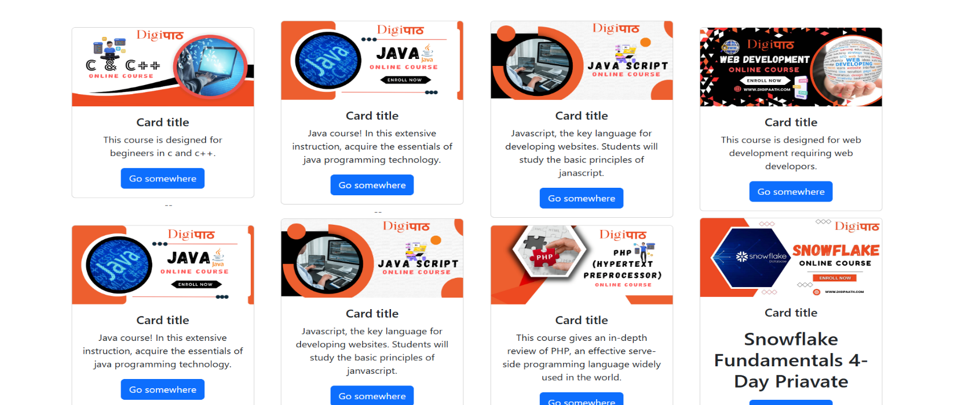

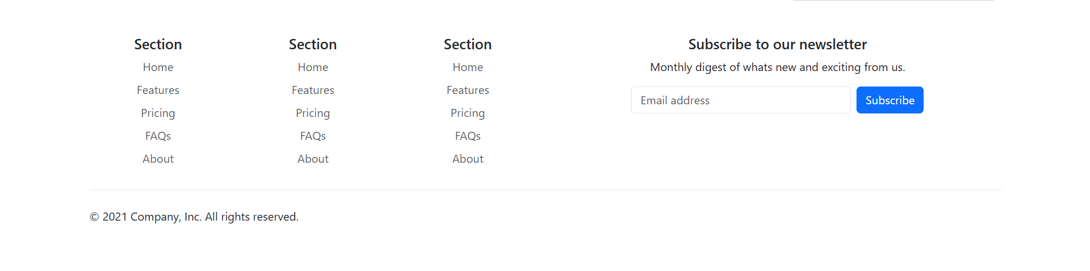 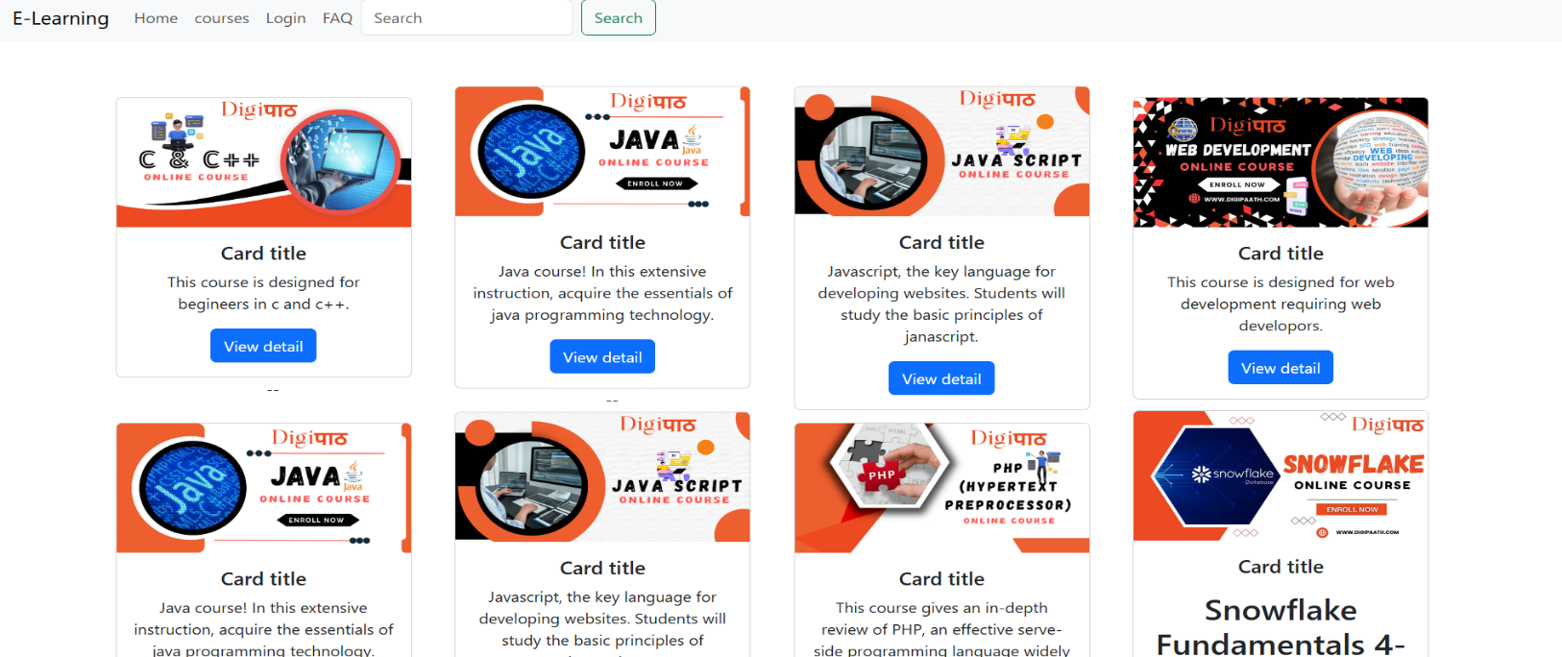

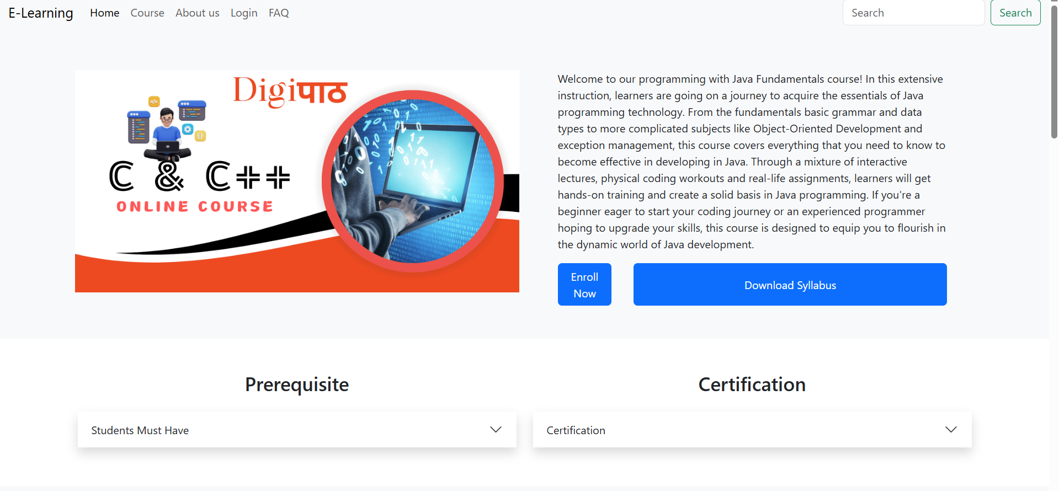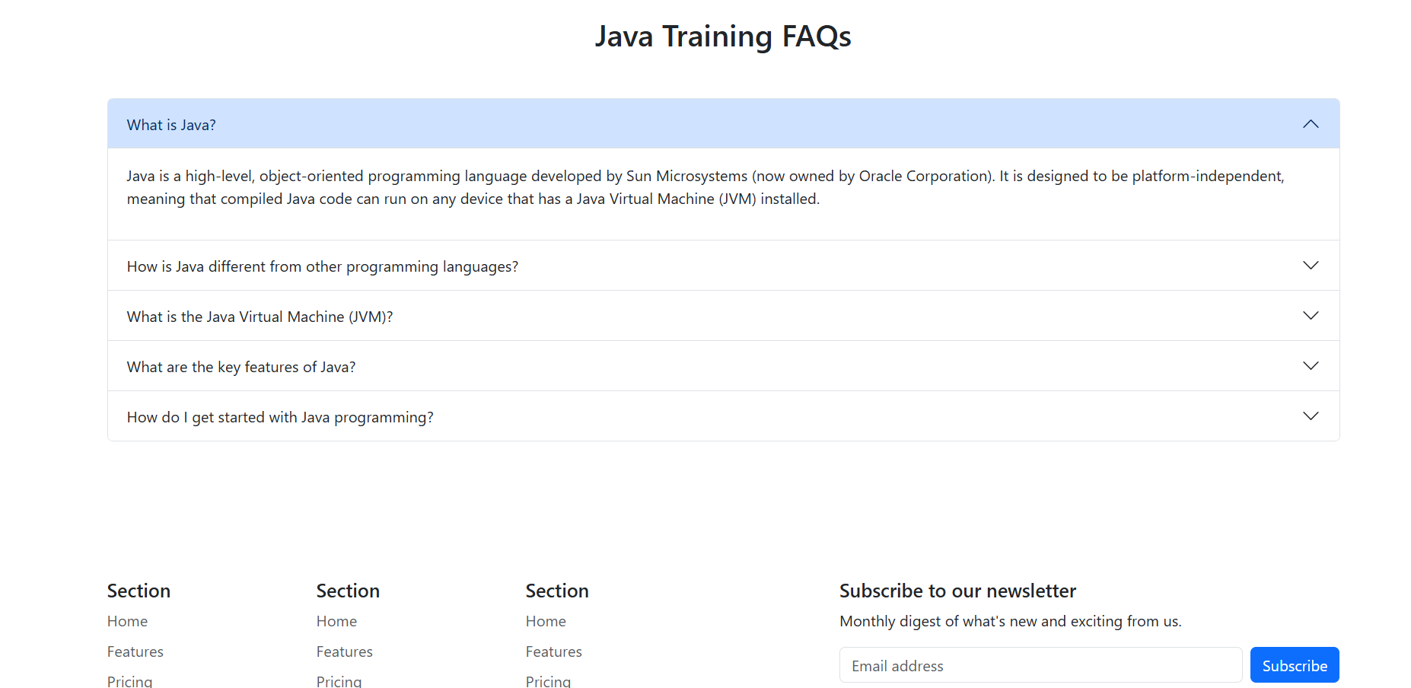

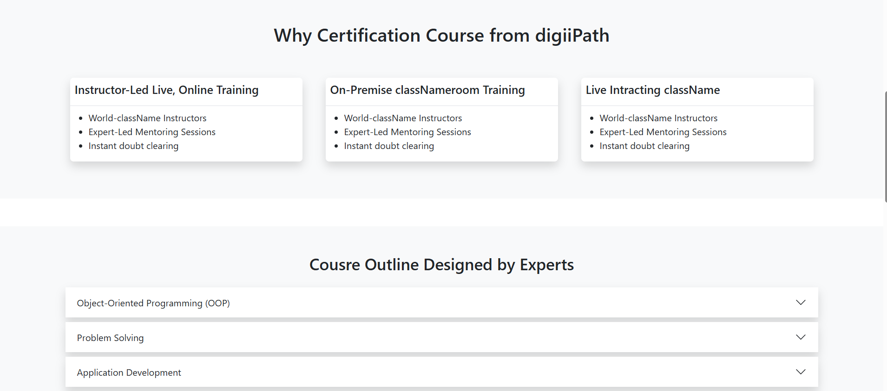

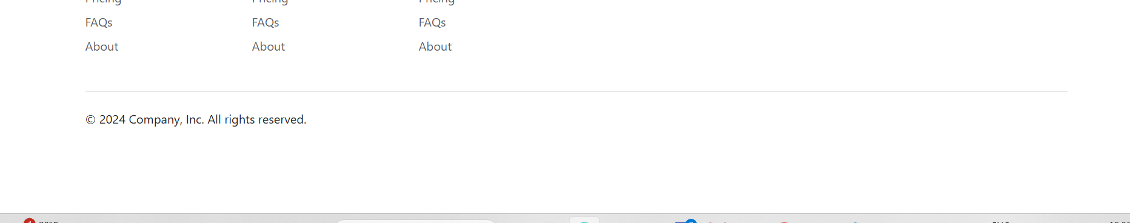 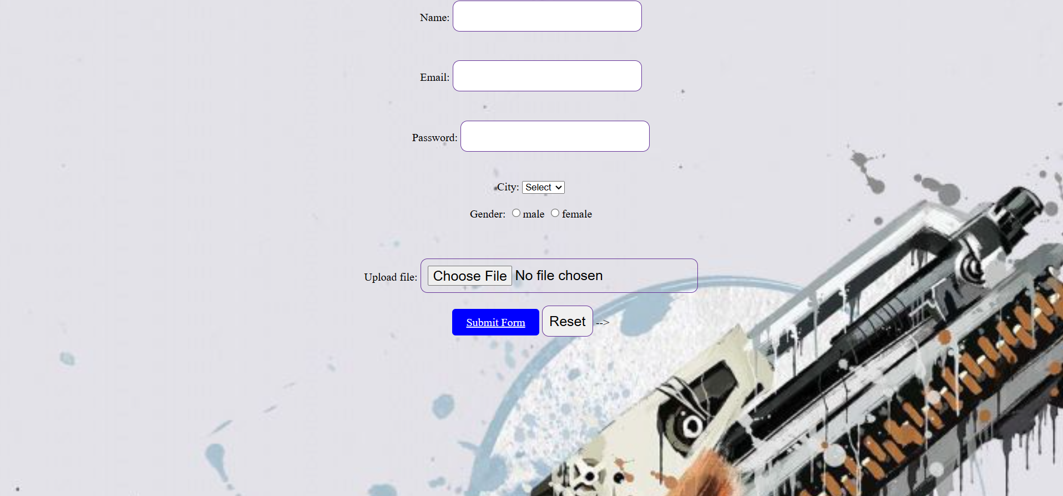

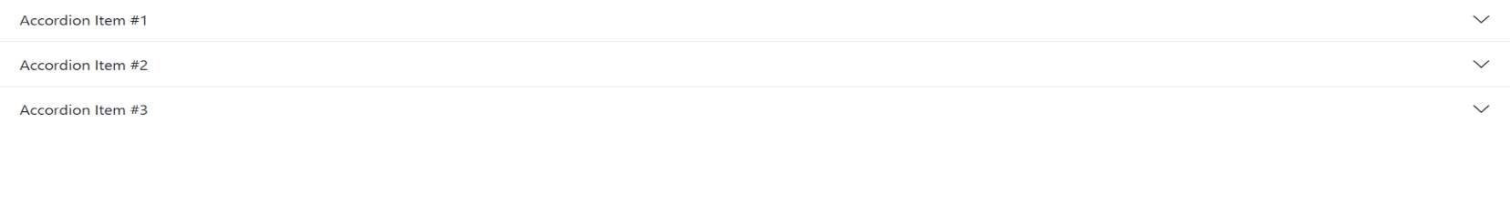

***Github Link:***

***https://github.com/krish230-stark/E-Learning.***

***Conclusion***

The provided HTML, CSS, and JavaScript code establishes a solid foundation for a basic e-learning website. It incorporates essential elements like navigation, content display, and a footer. However, to create a fully functional and engaging e-learning platform, several key enhancements are required:

**Core Functionalities:**

* **User Authentication and Authorization:** Implement robust user authentication and authorization mechanisms to secure user accounts and control access to different sections of the website.
* **Course Management System:** Develop a system for managing course content, including uploading videos, PDFs, and other materials. Allow instructors to create and organize courses.
* **Student Enrollment and Progress Tracking:** Enable students to enroll in courses, track their progress, and complete assignments.
* **Interactive Learning Tools:** Integrate features like quizzes, discussion forums, and interactive exercises to enhance the learning experience.
* **Payment Gateway Integration:** For paid courses, integrate a secure payment gateway to process fees and manage transactions.
* **Analytics and Reporting:** Implement tools to track user activity, course completion rates, and other relevant metrics.

**User Experience:**

* **Responsive Design:** Ensure the website is optimized for various screen sizes and devices to provide a seamless user experience.
* **Intuitive Navigation:** Design a clear and intuitive navigation structure to guide users through the website.
* **Visual Appeal:** Use visually appealing design elements, fonts, and color schemes to create an engaging user interface.
* **Accessibility:** Adhere to accessibility standards to make the website usable by people with disabilities.

**Security and Performance:**

* **Data Security:** Implement robust security measures to protect user data, including encryption and secure authentication protocols.
* **Performance Optimization:** Optimize website performance by minimizing load times, optimizing images, and leveraging caching techniques.

By addressing these aspects, you can transform the basic structure into a powerful and effective e-learning platform that caters to the needs of both learners and instructors.

*Reference:*

*The provided HTML code represents a well-structured foundation for an e-learning website. Here's a breakdown of the code and potential references for further development:*

***Structure:***

* ***Bootstrap:*** *The code utilizes Bootstrap, a popular CSS framework, for responsive design and layout elements like the navigation bar, carousel, and card layout. You can refer to the Bootstrap documentation (*[*https://getbootstrap.com/docs/5.3/getting-started/introduction/*](https://www.google.com/url?sa=E&source=gmail&q=https://getbootstrap.com/docs/5.3/getting-started/introduction/)*) for detailed usage instructions and component customization.*

***Content:***

* ***Navigation Bar:***

*The navbar includes links to potential sections like "Home," "Courses," "Login," and "FAQ." However, they are currently disabled. You can use Bootstrap's navigation component examples (*[*https://getbootstrap.com/docs/5.3/components/navs/*](https://www.google.com/url?sa=E&source=gmail&q=https://getbootstrap.com/docs/5.3/components/navs/)*) to configure these links and make them functional.*

* ***Carousel:*** *The code implements a carousel displaying images (presumably representing courses or promotions). Bootstrap provides a carousel component ([invalid URL removed]) that you can customize with image URLs, captions, and navigation controls.*
* ***Course Cards:*** *The website showcases course cards featuring images, titles, descriptions, and call-to-action buttons. You can further enhance these cards with details like instructor information, difficulty levels, and ratings.*

***Functionality:***

* ***Search Bar:*** *The website includes a search bar but lacks functionality. You can integrate a search script that connects to your course database to allow users to find specific courses.*

***Missing Elements:***

* ***User Accounts and Login:*** *Currently, there's no user login system. Consider implementing login and registration features to allow users to enroll in courses and track progress.*
* ***Course Content Management:*** *The code doesn't display actual course content. You'll need a backend system to manage and deliver course materials like videos, PDFs, and quizzes.*

*By incorporating these references and functionalities, you can transform this basic structure into a comprehensive e-learning website. Remember to prioritize user experience with clear navigation, informative content, and a user-friendly interface.*

*Sources and related content*